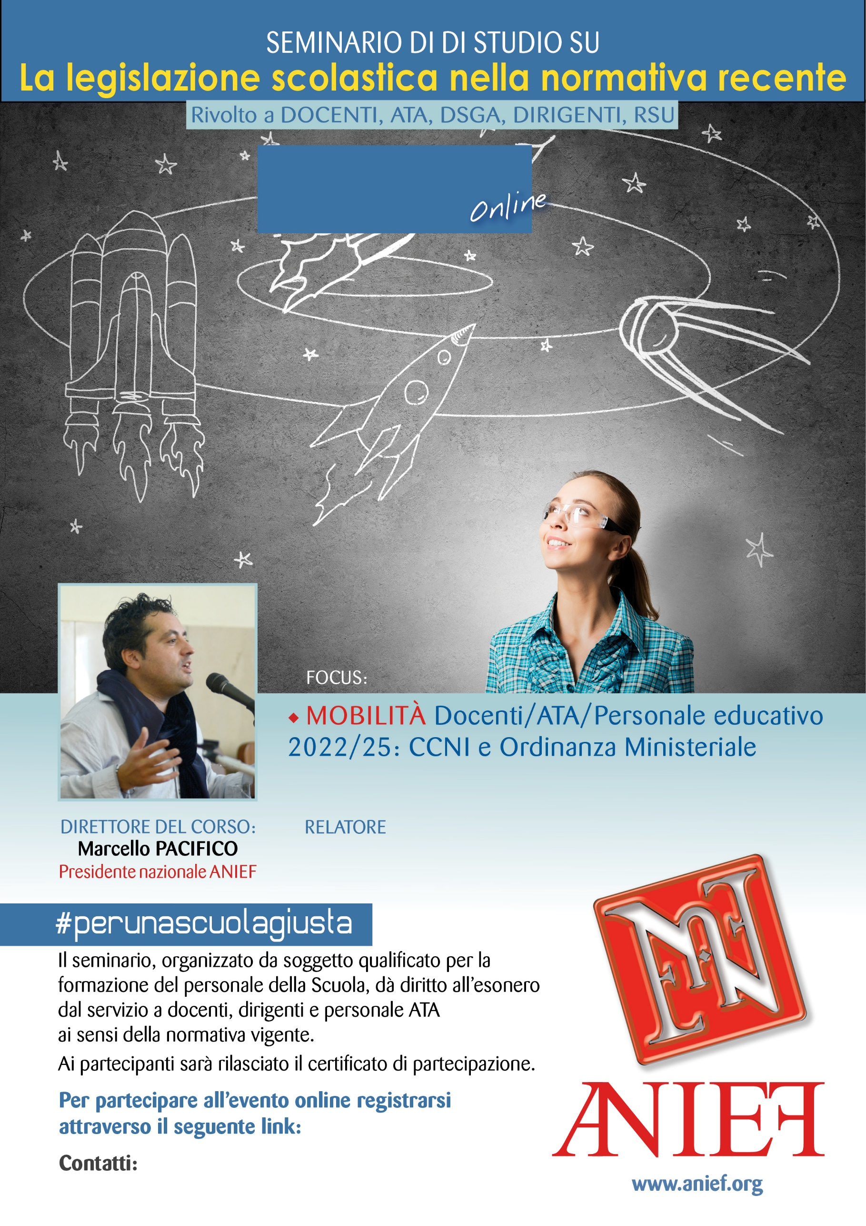

LINK DIRETTA: <https://anief.org/component/anief/dettaglievento?id=75049>

<emiliaromagna@anief.net>

FABIANA BRUNO

EMILIA ROMAGNA

11/03/2022 ORE 11:00 – 13:00